From: https://www.speedrun.com/helltaker/guide/3a3ef

I

↓ ← ← ← ← ← ← ← ↓ ↓ ← ↓ ↓ → → ↑ ↑ → → → → ↓ →

D,L till kill +1, 2D ,L,2D,2R,2U,4R,D,R

Second Option

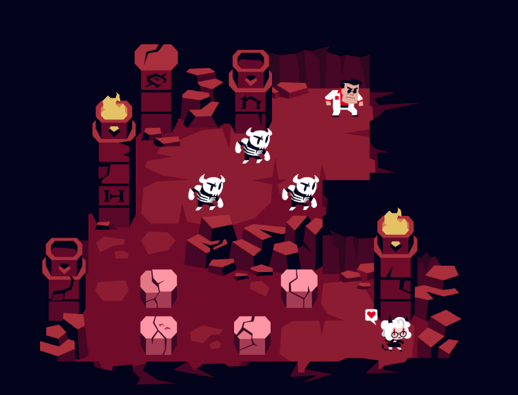

II

→ ↑ ↑ ↑ ↑ ↑ ↑ → → → ↓ → → ↓ ↓ ↓ ↓ ← ← ↓

R,U till kill+1,3R,D,2R,4D(2boulder),2L,D

Second Option

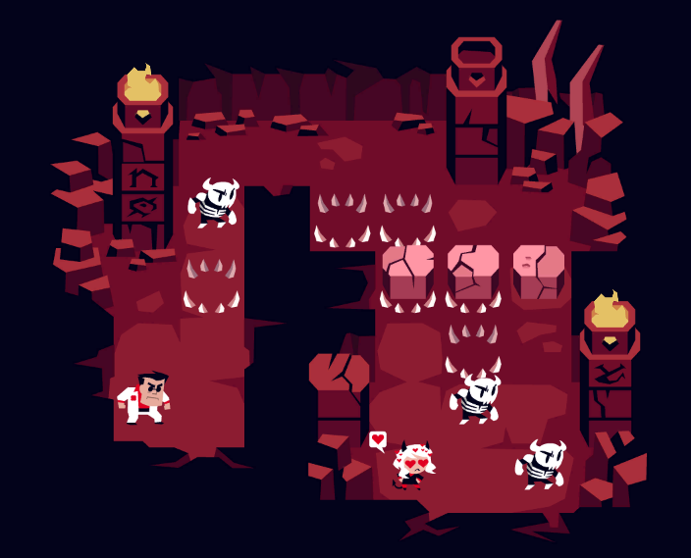

III

← ← ← ← ← ↓ ↓ ↓ ↓ ← ← ↑ ↓ → → → → → → → → ↑ ↑ ↑ ↑ ↑ ↑

5L,4D,2L,U(key),D, 8R (kill), 6Umash till dialogue

First option

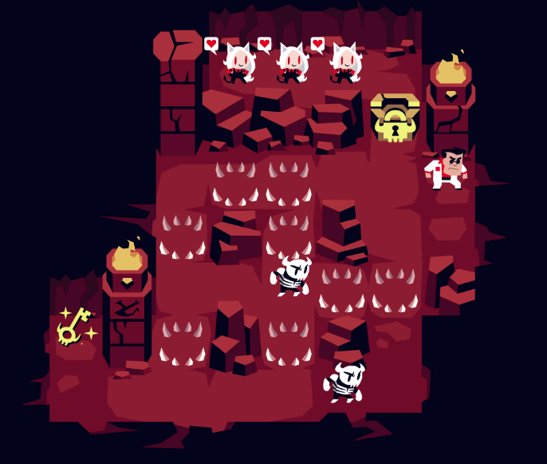

IV

↓ ↓ ↓ → ↓ ↓ → ↑ ↑ → ↓ ↓ → ↑ ↑ → → ↓ ↓ → → ↑ ↑

3D(1boulder),R,2D,R,2U,R,2D,R,2U,2R,2D,2R(TB),2U

First Option

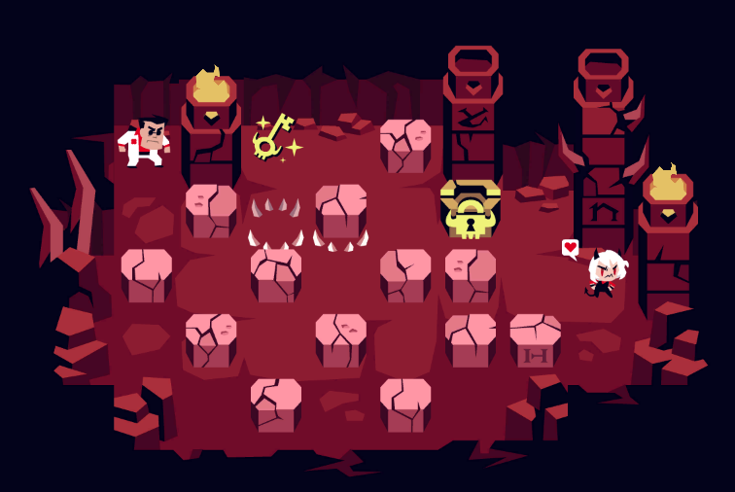

V

↓ ↓ ↓ ↓ → → → → → ↑ ↓ ↑ ↑ ← ↑ ↑ ← ← ↑ ↑↑

4D(kill+1), 5R, U,D(key),2U,L,2U,2L,3U

First Option

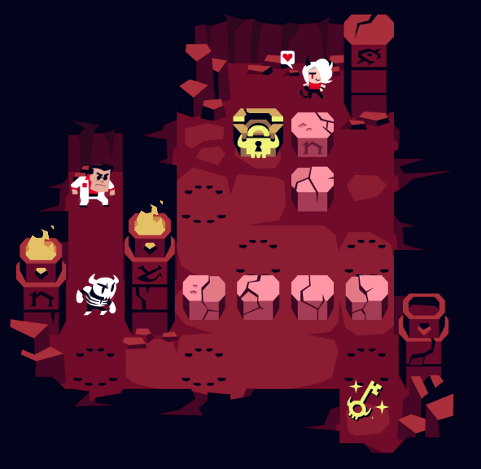

VI

← ↓ → → ↓ ↓ ← ← ↓ ← ← ↓ ↓ → → → → ↑ ↑ ← ← ↓ ↓ ↓ ↓ → → → ↑ ↑ → → → → ↓ ↓ ← ← ↓↓ L,D,2R,2D,2L (boulder sides),D,2L,2D(hit),4R,2U(key),2L,4D(kill+1),3R,2U,4R,2D(kill+1),2L,2D

First Option

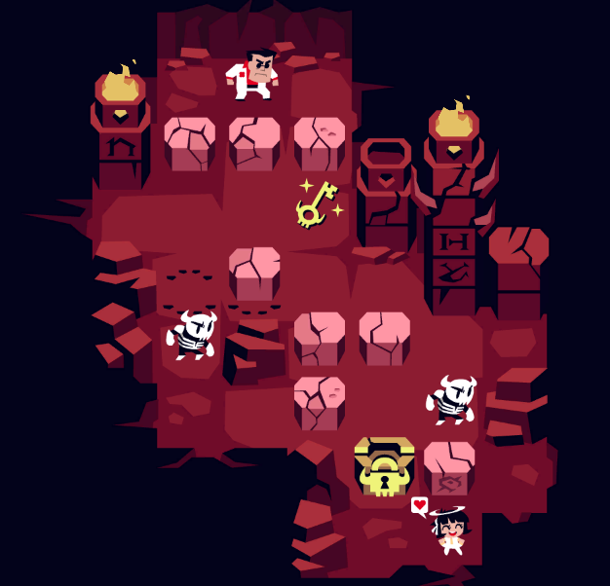

VII

↑ ↑ ↓ ← ← ↑ ↑ → ↓ ↓ ↓ ← ← ← ↑ ↑ ↑ ↑ → → ↑ ↓ → → → → ↑ ↑ → → ↑ ↑

2U,D,2L,2U(kill+1),R,3D,3L,4U(hit,nokill),2R,UD(key), 4R,2U,2R,2U

First option

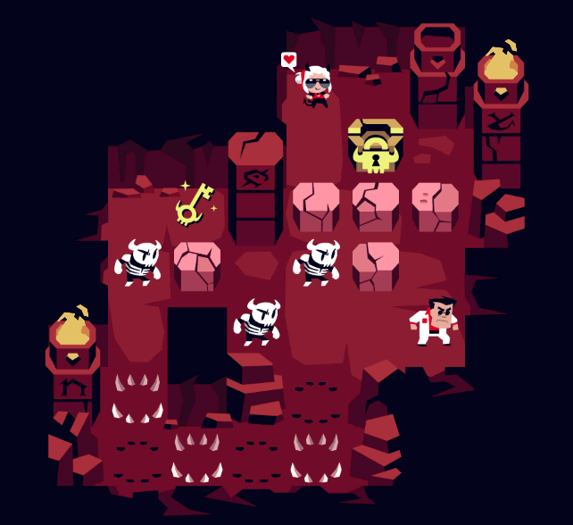

VIII

→ ↑ ↑ ↑ ↑ ↑ ↑ ↑ ↑ ↑ ← ←

R,9U,2L

Second option twice 2TB,D,x,TB,D,X

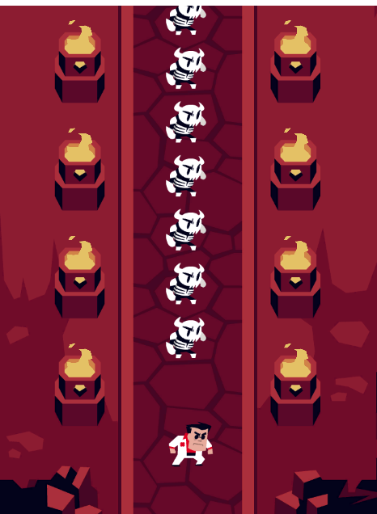

IX

→ ↑ ↑ → → → → ↓ → → ← ↑ ↑ ↑ → → → → ↓ ↓ → → ↑ ↑ → ← ← ← ↑ ↑ ↑ ← ↑

End the timer.

R,2U(push),4R,D,2R,L,3U,4R,2D,2R,2U,RL(key),2L,3U,L,U

